CALCULUS: CURVE SKETCHING
Fill in the answers.
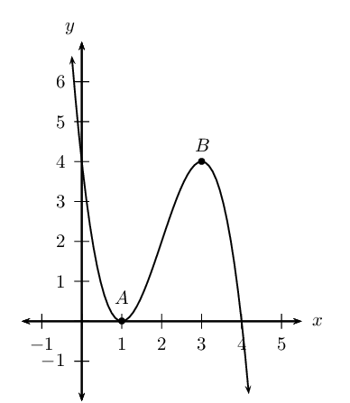
- The y - intercept is ( __; __ )
- The x – intercepts are ( __; __ ) , ( __; __ ) and ( __; __ )
- The coordinates of A are ( __; __ )
- The coordinates of B are ( __; __ )
- The general cubic function is y = ______________________
- The actual cubic function is f(x) = ______________________
- The x- values for which f(x) is increasing are _________________
- Given that f(x) = k, the values of k for which the graph has three roots are ___________________________
- The point of inflection is ________________
- The two turning points are ___ and ____

