FUNCTIONS
A function describes a specific relationship between two variables; where an independent (input) variable has exactly one dependent (output) variable. Every element in the domain maps to only one element in the range. Functions can be one-to-one relations or many-to-one relations. A many-to-one relation associates two or more values of the independent variable with a single value of the dependent variable. Functions allow us to visualize relationships in the form of graphs, which are much easier to read and interpret than lists of numbers.
Revision of grade 10 work:

Functions of the form y=a$x^{2}$+q

The effects of a and q on f(x)=a$x^{2}$+q:

a<0 a>0

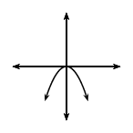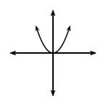

When a is positive When a is negative

‘Hill shape’ ‘Cup shape’

q<0 q>0
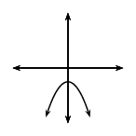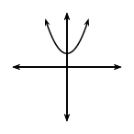
EXERCISE
Complete the table of values below and draw the graphs on the same Cartesian Plane below.
1. $y=x^{2}$
$$x$$ | -3 | -2 | -1 | 0 | 1 | 2 | 3
$$y$$

2. $y=-2x^{2}$
$$x$$ | -3 | -2 | -1 | 0 | 1 | 2 | 3
$$y$$

